**RADIANCE DATA PROJECT**

**Extracting** the **Data:**

* Python libraries pandas, numpy, geopandas, ee and geemap used to create shape files for assembly constituencies across India.
* Stored in a separate folder called “Constituencies” in “India Shape Files”.
* Night Time Light radiation data (NTL) collected in the form of time series data for 2021 and 2022, for each assembly constituency per month.

**Extracting NTL data:**

* Separate shape files created for each assembly constituency in the folder shape India.
* Some of the constituency names are repeating for which unique names are assigned.
* Python code written to extract mean of the average radiation per month over the years 2021 and 2022 across each assembly constituency.
* Data extracted from satellite earth imagery VIIRS dataset using ee and geemap modules.
* Shape files are iterated to extract mean radiation per month.

**STEPS:**

1. We import all the necessary libraries required for the extraction.
2. We then authenticate our access to the google earth engine. For this, we give in an email ID and the name of our project. The google earth server asks us the degree of permission we want to grant and we select it according to our needs. We are then given an access code that we paste into the jupyter notebook interface and press Enter.

Screenshots of the same:

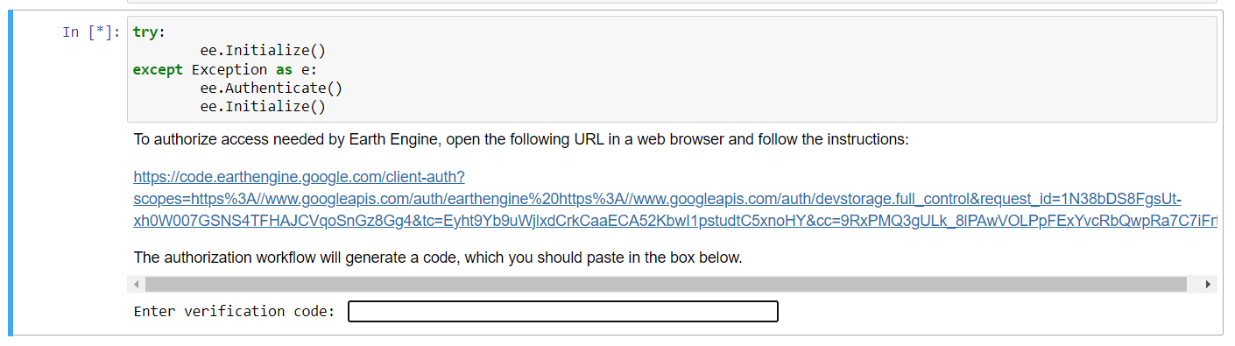

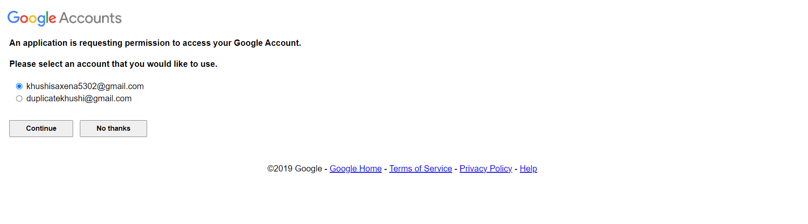

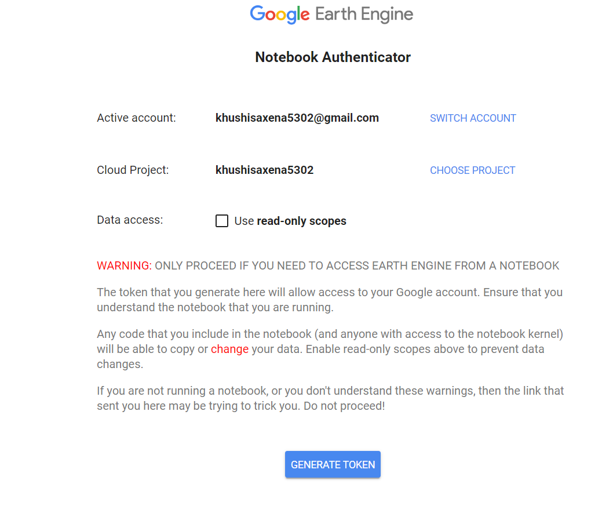

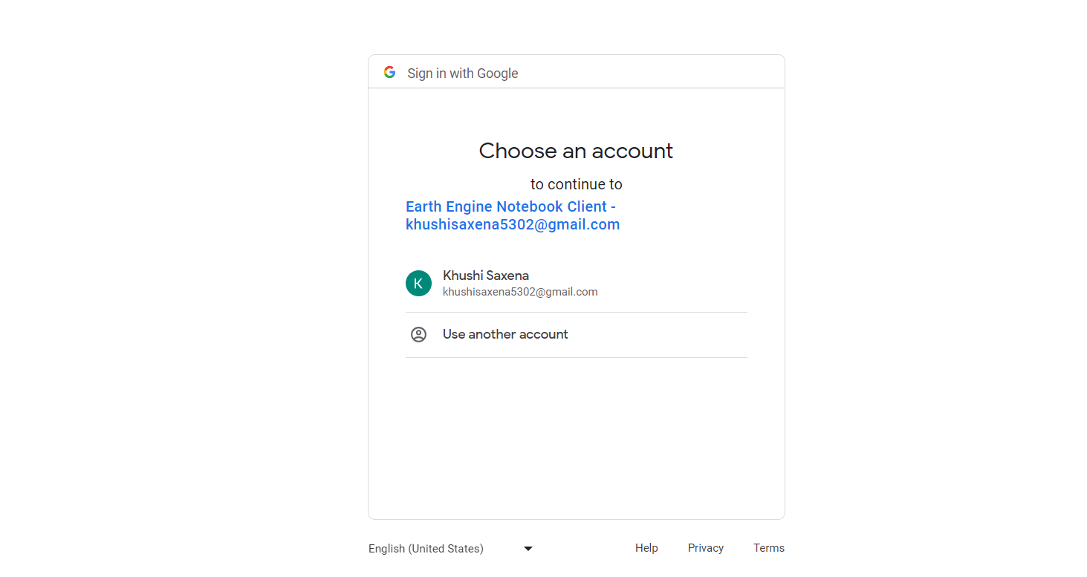





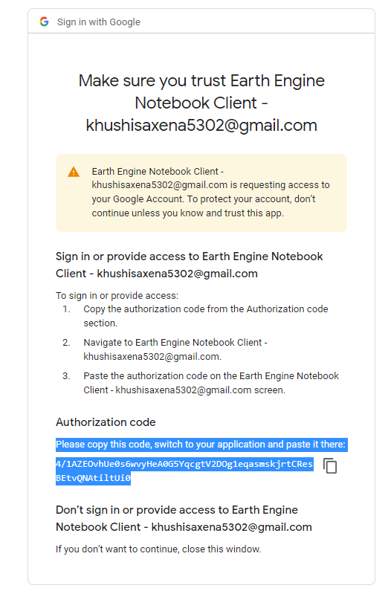

1. We then load the dataset and generate a shape file for each assembly constituency.
2. The data for each constituency is fetched using earth engine’s VIIRS dataset and appended into a dictionary. We can set the duration according to our own need.
3. The dictionary is then used to create a dataframe and the dataframe is downloaded as a csv file.